**March 20th 2017**

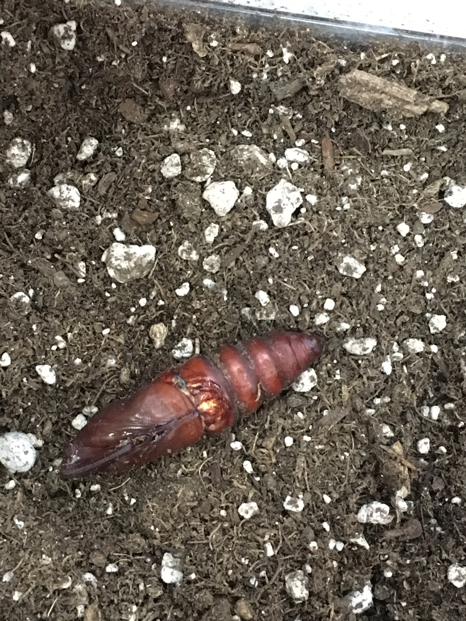

**Largest Manduca Caterpillar that pupated first, was dug up first on the 18th and does not look good, has an issue with the outer coating.**

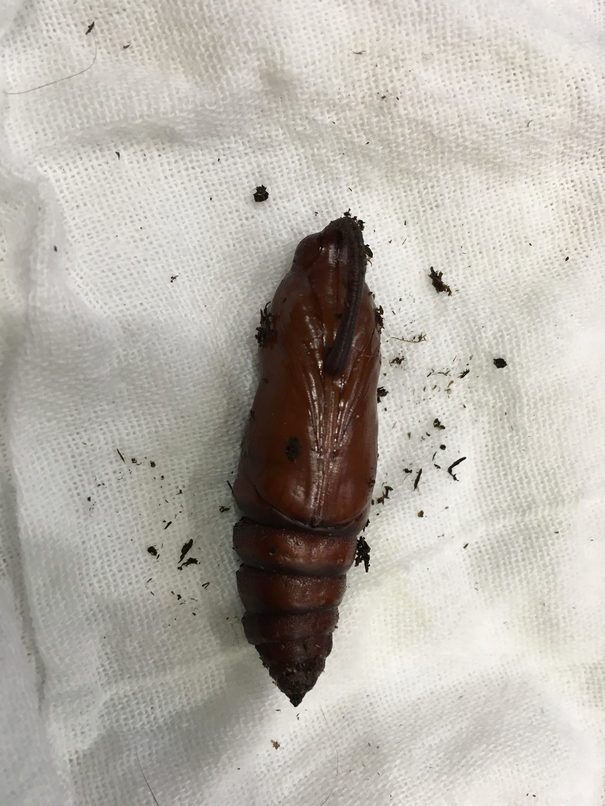

**Medium sized caterpillar, has an outside that looks good, no holes like one above, and the proboscises looks well formed.**